Class 3 – HRHG

- Fill in the blanks. (4×1=4)
Disease, milk, eastern, family
- ________ is our first school.
- Ratnanagar lies in ________ part of Chitwan.
- Dairy products made from ________.
- Medicinal plants are important to cure ________.

- Write ‘T’ for True and ‘F’ for False in given statements. (4×1=4)
- There are 16 wards in Ratnanagar. ( )
- We do not have advantages from the wildlife. ( )
- Games help us to refresh our body and mind. ( )
- Tourism increases the economy of our country. ( )

- Write the names of the followings: (0.5×6=3)
- Two tourist destinations:
i. __________________ ii. _________________

- Two indoor games:
i. __________________ ii. _________________

- Two dairy products:
i. __________________ ii. _________________

- Identify the following pictures. (3×1=3)
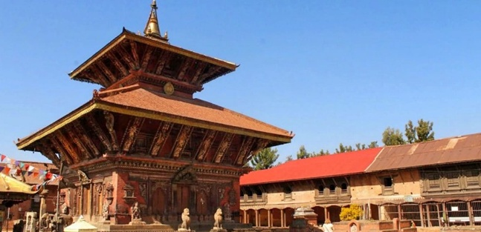
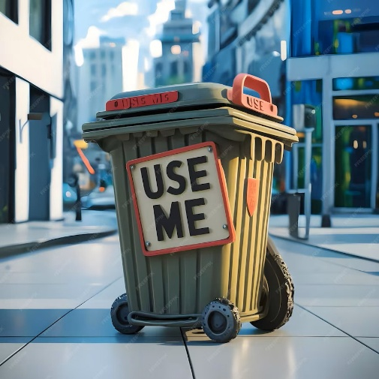
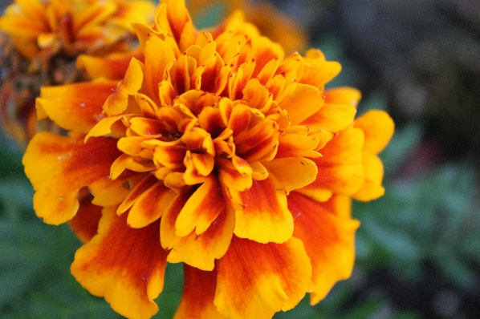
- Answer the following questions. (4×2=8)
- Write any two neighbouring municipality of Ratnanagar.
- Why are medicinal plants important?
- Define local games.
- What is the main occupation of a farmer?

- Draw a picture of water resource (any one). (3)

